**HOME AUTOMATION USING IOT**

In every corner of the globe, there is nothing but a talk about the Internet of Things. Wherever you look it is all about the Internet of Things. It’s a formidable and vast thing in innovation. It has the potential to change the world and now look at how it is shaping the way we live.

I’ll give you an example. Suppose that you were somewhere out and suddenly realized that you had left your air conditioner turned on and now you can not go long way back for it. So in such a circumstance, what if you could simply use your smartphone to turn it off? Wouldn’t that be incredible?

The **Internet of Things** (IoT) is a scenario in which almost every appliance can be connected to the internet and can be monitored using a remote.

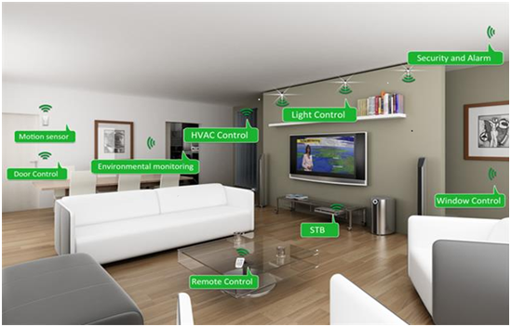

The **Internet of Things** (IoT) refers to a system of internet-connected objects that are embedded with sensors and software to collect and transfer data over wireless networks.

Just Imagine being woken up by your morning alarm, the windows automatically open, and when you speak your assistant lets you know the weather for the day. The light turns on, the temperature of your home is set, and the door is locked just by talking to it. It’s so much easier now to get up in the morning having your coffee maker brewing while your stereo is playing music. You can enter and exit your home with face recognition. The lights can even be scheduled to turn on and off. Isn’t this amazing?

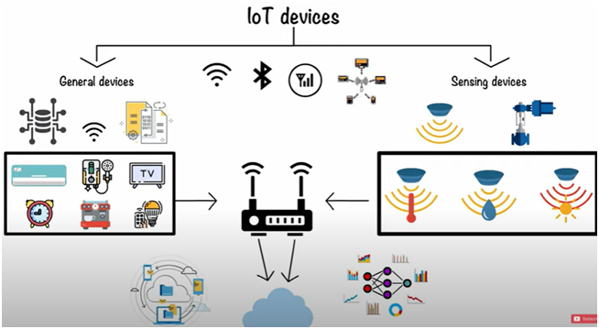

How IoT helps in transferring data over wireless networks?

So, the device that can be connected to the internet and has a sensor through which it can transmit data, such a device can be considered as an IoT device. These devices help in transferring the data over wireless networks.

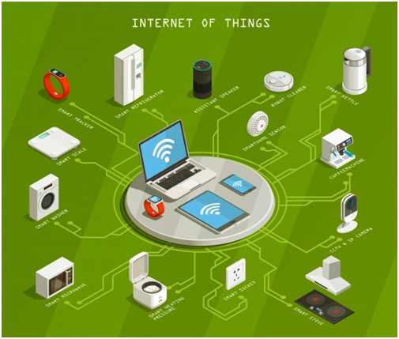

Devices are well connected and a lot of components are involved in transferring data. IoT devices are equipped with sensors and processors that collect data. The sensor collects data via machine learning. Machine learning is a method of analyzing data. Machine learning’ is a type of Artificial Intelligence in which computers learn without human intervention, i.e. without being programmed.

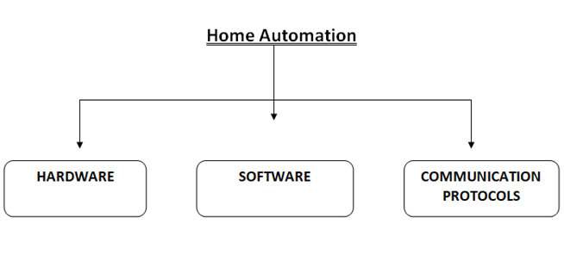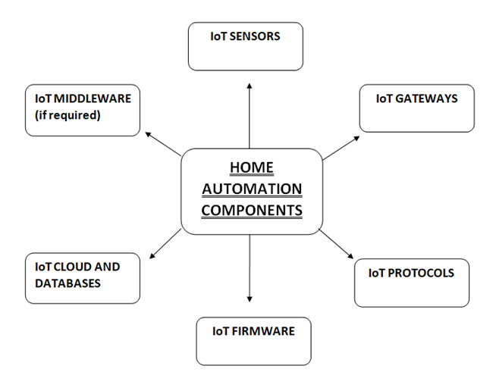

Home Automation using IoT has sensors and servers in general. As we know the servers collect data, the next step will be to manage and process the same data without a personal computer, which will be possible with the use of servers.

The following home automation gateways are available:

· Supported communication protocols

· The ability to work in real-time

· Support for MQTT, CoAP, and HTTPS

Aspects of security and configuration

The modularity of the system

The gateway is the main controller that is connected to the home route. This is the key part as all communications, monitoring, controlling, transferring and the receiving of commands are done through the gateway. The controller does not establish a fixed route between devices, it sends the signal via the shortest path available to the sensors either directly or through hops, and if the path is occupied it uses another path within the network.

Whenever signals arrive at their destination, actions are initiated and users are alerted through email, SMS, voice calls, etc.

Protocols for home automation:

· Bluetooth low energy and Bluetooth Smart

· Wireless Zigbee

· X10

· Insteon

· Z-wave

· Wifi

· UPB

· Thread

· ANT

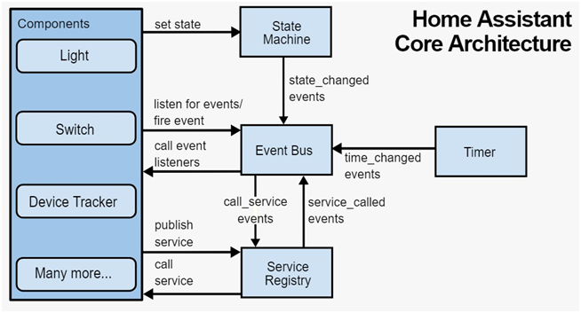

There is more potential in the IoT. By 2025, there will be 80 billion connected devices, up from 23 billion in 2018. With the growth of IoT and connected devices, our quality of life is going to improve.

IoT collaborates with a variety of fields, based on the latest IoT trends 2020. IoT enables all other fields to succeed. IoT is imperative.

So, the Internet of Things is a vision where every object could connect to the internet to gain actionable insights.